Get – Post – Put – Delete from API

<https://johncodeos.com/how-to-make-post-get-update-and-delete-requests-with-urlsession-using-swift/>

**Core Data Basics**

For an iOS application to use a database, it relies on a Cocoa API known as  *Core Data.*For those of you familiar with SQL, you probably want to separate the concept of "database" into two kinds: There are relational databases, which is what you're probably used to, and object databases, which is what Core Data provides.

In a relational database, the key actions are  *select* (SELECT * FROM *table_name*) and *transaction* (INSERT, UPDATE or DELETE). In the *select,*we ask the database to form itself into a collection of columns (through JOIN statements), filter and sort according to some set of rules, and then return a linear collection of rows. In the *transaction*, we inform the system that we are performing some series of data transformations, we then commit the transaction. A great model but Core Data doesn't look much like it.

The main adjustments for developers coming from RDBMS-land (Relational Database Management System) transitioning to Core Data are:

1. The concept of Unique Identifiers (Primary keys) - They are going on behind the scenes but you never have to worry about them and should not try to define your own.
2. Setting up relationships between objects - We don't save the unique ID of a related object, instead, we use Swift semantics to relate the objects.
3. Data Normalization - You don't need to worry about data normalization in Core Data. In practice, you still need to worry about good data design, because that's always important, but you don't need to worry as much about the underlying implementation details as in an SQL database.

Core Data is hardware-agnostic. Runtime support is available on the same processors that MacOS X and iOS support. Plus, Core Data works directly with SQLite, the public-domain database engine bundled with MacOS X and iOS.

Although useful, we would not consider  **plists** for anything other than saving simple preferences and really basic data such as remembering preferred default language, audio/video preferences, default templates, etc.

Performance wise, retrieving and saving data to plists can be quite slow.

Core Data will give you the flexibility to expand your object models as needed, easily fetch objects from the persistent storage based on certain parameters, create relationships between models (One-to-Many, One-to-One), memory management, etc.

* Core Data manages to save and undo functionality for you. It has a persistent store, which tracks changes, and can be flushed to the disk automatically at any number of times (app close, etc.).
* Core Data and related classes provide easy ways to get your entities into UITableViews, like NSFetchedResultsController.
* Core Data abstracts away a lot of the messy things you'd otherwise have to deal with yourself, such as lists of objects, one-to-many or many-to-many relationships, or constraints on object attributes, into a single nice clean object-oriented interface.
* Core Data comes with a nice graphical object model editor that can help you think through your object/entity design, and refine it as you go.
* Supports migration.

**Let's Start!**

**Step 1: Initial Configuration**

1. Create a new Project (Single View Application) and name it **HelloCoreData.**
2. Make sure you check *Use Core Data*in the **Choose options for your new project**before proceeding to the next step. Checking the Use Core Data box will cause Xcode to generate codes for what's known as Core Data stack in **AppDelegate.swift.**
3. Once done, you will see a new file included to your project:
   1. A file with **.xcdatamodeld**extension. This is like XCode's version of MySQL Workbench where you can create Entities and Attributes (or Tables and Columns in SQL), establish object relationships, etc.
4. Create a new Entity by clicking **.xcdatamodeld**file. Name this Entity as **User**

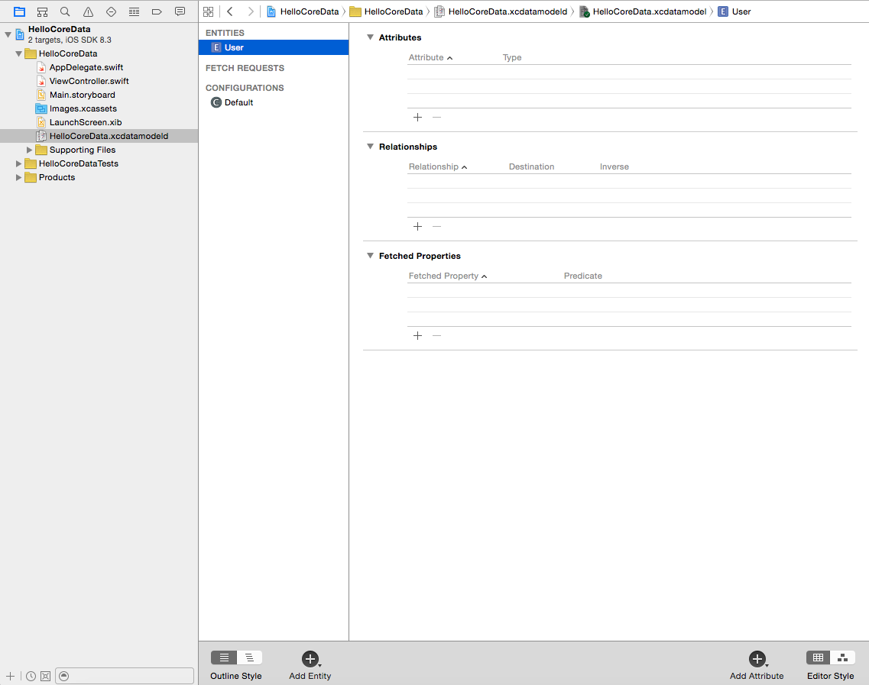

1. Create two attributes *firstName*and *email*both as type *String.*

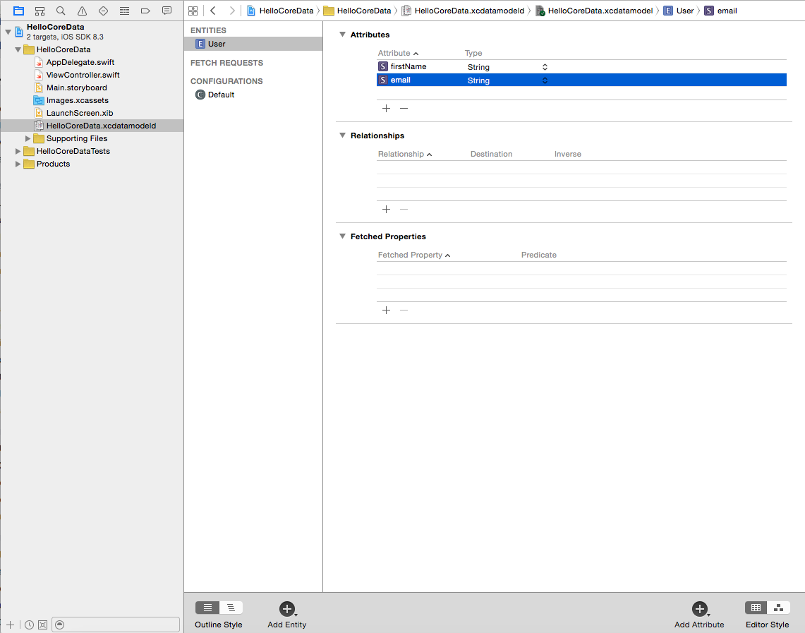

1. Click on the Entity name ("User") and, on the right-hand side, change the 'Module' property under 'Class' to be 'Current Product Module'.



Launch your app just to make sure we are free from errors. Before proceeding to the next step, close and re-open your project. This will load the 'User' class into your project that Core Data automatically created when we defined our Entity.

**Step 2: Save Button**

1. Drag a Button to your View Controller. Change the button text to *Save.*
2. Ctrl + Drag button to your View Controller. Set *Connection*to **Action,**the *Name*to **saveUser,**and *Type*to **UIButton**

**Step 3: Connect to Core Data**

• In our **ViewController.swift,***import CoreData.*

• Create an instance (that reference to the app delegate's managedObjectContext) to your **ViewController.swift**file**.**This will enable you to communicate with Core Data (its like a scratch pad for our data. Before we commit our request to Core Data, we first need to write what we want (retrieve or save) in NSManagedObject:

let managedObjectContext = (UIApplication.shared.delegate as! AppDelegate).persistentContainer.viewContext

• Link the Entity definition (**User.swift**file) to NSManagedObject whenever the saveUser method is invoked with this code: (Add these codes within *saveUser*method)

let user = User(context: managedObjectContext)

**Final Step: Save**

• in the saveUser method, let's add this code:

// Under the 'saveUser' method, after the 'let user = ....' statement

user.firstName = "Bob"

user.email = "Bob@bobmail.com"

• Let's commit our "setValues" above. Add these codes at the bottom of your *saveUser()* method:

if managedObjectContext.hasChanges {

do {

try managedObjectContext.save()

print("Success!")

} catch {

let nserror = error as NSError

print("Unresolved error \(nserror), \(nserror.userInfo)")

abort()

}

}

• save() method requires one parameter, which is a pointer to an NSError. If there is an error with the commit operation, then the error variable will catch that error and you can simply inspect the error or alert the user if necessary.

• Run your app and click the Save button.

If you see a "Success!" message in the console, Congratulations!

**Save Multiple Objects:**

We will paste this snippet inside the *viewDidLoad()*method. The code below is just temporary for us to save multiple records in one go. Know that there are cleaner ways of grabbing data (via Text Input) and saving those in Core Data, but it involves more work and at this point we just want to make things simpler. For now, let's just insert stuff to DB manually.

override func viewDidLoad() {

super.viewDidLoad()

let users = [

["firstName": "John", "email": "john.blake@example.com"],

["firstName": "Rodney", "email": "rodney.roberts20@example.com"]

]

users.forEach {

user in

let newUser = User(context: managedObjectContext) // Should have been declared as a constant within the ViewController's scope

newUser.firstName = user["firstName"]

newUser.email = user["email"]

do {

try managedObjectContext.save()

print("Success")

} catch {

print("Unresolved error \(error)")

abort()

}

}

}

**Load & Delete**

Using the  **HelloCoreData**projectfrom the Core Data basics tab, we are going to extend it by letting us print the items saved from the User entity.

Let's display the values in the console every time we open the app (The following codes should be added within the  *viewDidAppear*method):

1. Create a *viewDidAppear(animated: Bool)*method:
2. override func viewDidAppear(_ animated: Bool) {
3. super.viewDidAppear(animated)
4. }
5. Tell Core Data that we want to fetch items from the *User*entity:
6. do {
7. let userRequest = try managedObjectContext.fetch(User.fetchRequest())
8. } catch {
9. print("Error: \(error)")

}

1. Finally, we iterate through records saved within the *User*entity:
2. userRequest.forEach {
3. user in
4. if let thisUser = user as? User {
5. if let email = thisUser.email, let firstName = thisUser.firstName {
6. print("Email: \(email), First Name: \(firstName)")
7. }
8. }
9. }

You will see rows of "Oliver"s in the console with each corresponding email. Let's print these out on a Table View!

Let's create a new Project for this tutorial and name it as "Journal".

1. Click on **Main.storyboard** and delete the default View Controller  on the right side by pressing DELETE on your keyboard
2. Delete the default **ViewController.swift** file
3. Drag a *Table View Controller* on your Story Board.
4. Create a new File by right clicking on the Journal project and select New File... Under iOS Source, Choose *Cocoa Touch Class.*Click Next.
5. *Class:***JournalTableViewController***Subclass of:***UITableViewController***Language:***Swift**Click Next > Create  
     
   This will create a  **JournalTableViewController.swift**file. Remove the unnecessary comments. Remove the methods except for *viewDidLoad*and *didReceiveMemoryWarning*



1. Click **Main.storyboard**fileand Click on the new Table View Controller on right side. go to *Attributes Inspector (4th icon in right panel)*and check *Is Initial View Controller*option. Then go to *Show the Identity Inspector (3rd icon in right panel),*and type in **JournalTableViewController**as *Class*:

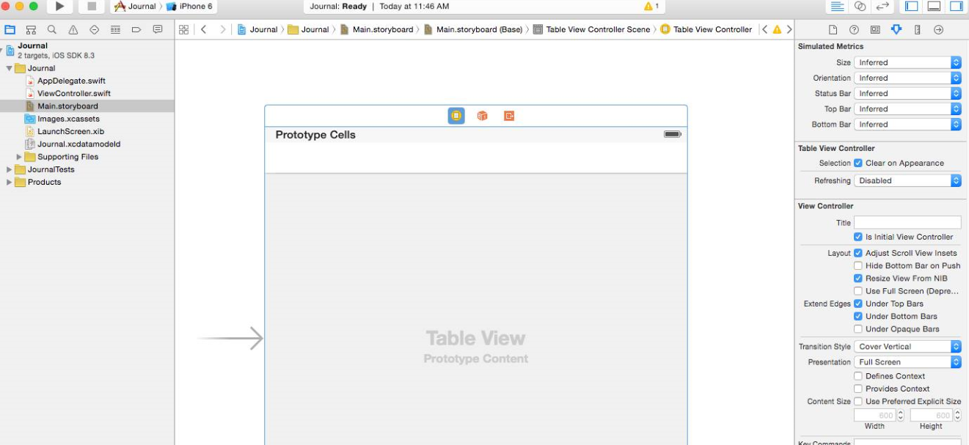

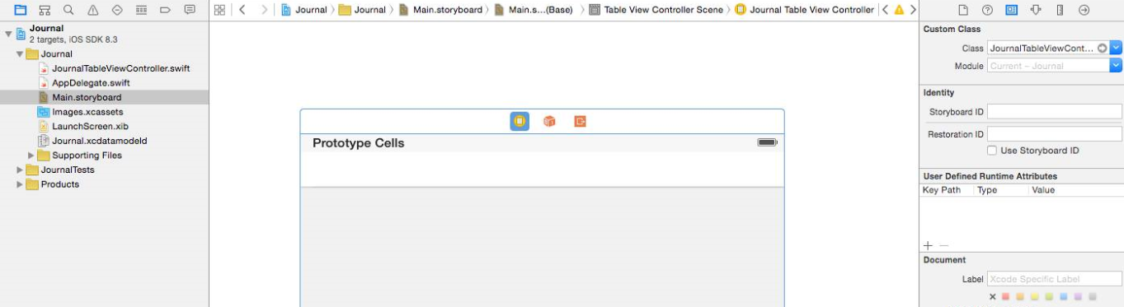

1. Click **Main.storyboard**file and Show the *Document Outline.*Under *Table View*, click *Table View Cell*and on the right Panel, under *Show the Attributes inspector,* put "Cell" as the **Table View Cell**'s*Identifier*then press Enter*:*

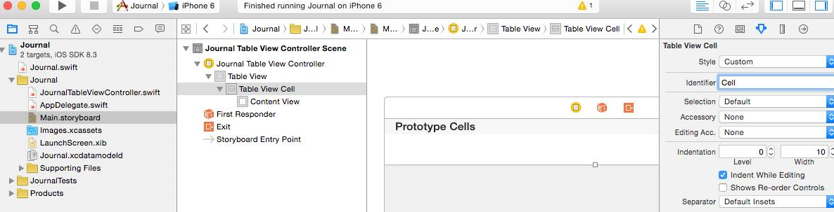

1. Click **Journal.xcdatamodeld.**Add a new entity by Clicking on **Add Entity.**Name this entity as "Journal"
2. Create two attributes for this Entity by clicking **Add Attribute:***title*and *journalDescription*both of type String.
3. Click the *Journal* Entity. On the right panel, under *Show the Data Model Inspector,*change the *Module* property from 'Global namespace' to 'Current Product Module'.core
4. Save your project and build it (Cmd + R) to make sure we have no errors. Once this is done, you should have access to the *Journal* class in your project.
   1. If you don't have access to the *Journal* class, close and reopen Xcode and try again.
   2. 
5. Open **JournalTableViewController.**Make sure you import Core Data.
6. import UIKit

import CoreData

1. Create an *IBOutlet, managedObjectContext,*and *Journal*instance variablesin **JournalTableViewController.swift**
2. class JournalTableViewController: UITableViewController {
3. var journal = [Journal]()
4. var managedObjectContext = (UIApplication.shared.delegate as! AppDelegate).persistentContainer.viewContext
5. ...

}

1. Paste these codes within *viewDidLoad()*
2. override func viewDidLoad() {
3. super.viewDidLoad()
4. do {
5. let journal = try managedObjectContext.fetch(Journal.fetchRequest())
6. } catch {
7. print("Error: \(error)")
8. }

}

1. Replace *Return 0*with the code below in the *tableView(cellForRowAtIndexPath)*method:
2. override func tableView(_ tableView: UITableView, numberOfRowsInSection section: Int) -> Int {
3. return journal.count

}

1. Paste these codes within *tableView(cellForRowAtIndexPath)*method
2. override func tableView(_ tableView: UITableView, cellForRowAt indexPath: IndexPath) -> UITableViewCell {
3. let cell = tableView.dequeueReusableCell(withIdentifier: "Cell")!
4. let journalItem = journal[indexPath.row]
5. cell.textLabel!.text = journalItem.title
6. return cell

}

Run your app and make sure there are no errors. If everything goes smoothly, you will see a blank table view. Which is obvious because we haven't persisted anything yet. But the app is basically ready to display Journals. Earlier we manually persisted items to Core Data, let's make it a little bit more interesting this time. Let's add a form to insert stuff!

**Persist via Form**

1. Embed the View Controller in a navigation controller. Go to XCode's **Editor**menu, select **Embed In...\ Navigation Controller**
2. Drag a Bar Button Item and place it on the View Controller's newly added navigation bar. Then go to *Attributes Inspector*and change Bar Button Item's *System Item* propertyto **Add.** The button should now be a '+' symbol.
3. Ctrl-drag from the **Add**bar button item onto **JournalTableViewController.swift.**Create an *Action*and name the method *addJournal.*Type should be *UIBarButtonItem*
4. Copy and paste the codes below within the *addJournal*method:

@IBAction func addJournal(_ sender: UIBarButtonItem) {

// Copy everything from here down

let alert = UIAlertController(title: "New Entry",

message: "Add a new journal entry",

preferredStyle: .alert)

alert.addTextField(configurationHandler: nil)

let saveAction = UIAlertAction(title: "Save", style: .default)

{

_ in

let textField = alert.textFields![0]

let newJournalEntry = Journal(context: self.managedObjectContext)

newJournalEntry.title = textField.text!

newJournalEntry.createdAt = Date() as NSDate!

self.saveJournalEntries()

}

let cancelAction = UIAlertAction(title: "Cancel", style: .cancel, handler: nil)

alert.addAction(saveAction)

alert.addAction(cancelAction)

present(alert, animated: true, completion: nil)

}

func saveJournalEntries() {

do {

try managedObjectContext.save()

print("Successfully saved")

} catch {

print("Error when saving: \(error)")

}

fetchJournalEntries()

}

func fetchJournalEntries() {

do {

journal = try managedObjectContext.fetch(Journal.fetchRequest())

print("Success")

} catch {

print("Error: \(error)")

}

tableView.reloadData()

}

**To Delete a ROW**

override func tableView(_ tableView: UITableView, commit editingStyle: UITableViewCellEditingStyle, forRowAt indexPath: IndexPath) {

managedObjectContext.delete(journal[indexPath.row])

self.saveJournalEntries()

}

**Migrations**

Migration allows you to define changes to your Schema, making it possible to use a *version control* system to keep things synchronized with the app's codes. If you have a Core Data model in your app, and you want to make some changes to that model (Add, rename, change the data type, or delete: attribute, entity), you need to do a migration.

Try adding an attribute to our Journal app's Model and then run it. Your app might crash!

To tell Core Data about the changes we've made to our Model, we need to:

1. Do not modify your Model just yet. If you made some changes, make sure you undo those changes before you perform the migration.
2. Click on your **xcdatamodeld**file. Go to *Editor >****Add Model Version***
3. Under Version name, it's a convention to append an incrementing number to the model name. Example: **Journal2.**(Remove the space). Click **Finish.**
4. You will notice that your **xcdatamodeld**file now has a triangle icon beside it. Click on it to expand. You will see two files within it: The model version you just created, and the model which your app is currently using (The one with the green check mark). Click on the model version you just created and modify it by adding a new attribute.
5. We need to tell Core Data that we will be using the new Model as the default model for our app. Click on the main **xcdatamodeld**file. Select the *Journal* entity, and in the right-side panel under *File Inspector* (first icon), change *Model Version* to the new Model we just created.

And that's it! You now have successfully included migration to your XCode project and should be able to run your app using the updated Model without errors.